Docker
Ahmed Ehab Ahmed
Lab-1

Proplem 0:
- Download Docker and
- Run docker without sudo
sudo apt-get update
sudo apt-get install ca-certificates curl gnupg lsb-release
sudo mkdir -p /etc/apt/keyrings
curl -fsSL https://download.docker.com/linux/ubuntu/gpg | sudo gpg --dearmor -o /etc/apt/keyrings/docker.gpg
echo "deb [arch=$(dpkg --print-architecture) signed-by=/etc/apt/keyrings/docker.gpg] https://download.docker.com/linux/ubuntu $(lsb_release -cs) stable" | sudo tee /etc/apt/sources.list.d/docker.list > /dev/null
sudo apt-get update
sudo apt-get install docker-ce docker-ce-cli containerd.io docker-compose-plugin

sudo usermod -aG docker ahmed
newgrp docker

Problem 1:
- Run the container hello-world
- Check the container status
- Start the stopped container
- Remove the container
- Remove the image

docker run hello-world
docker ps -a
docker start -a 9b39f14eead5
docker rm 9b39f14eead5
docker rmi hello-world
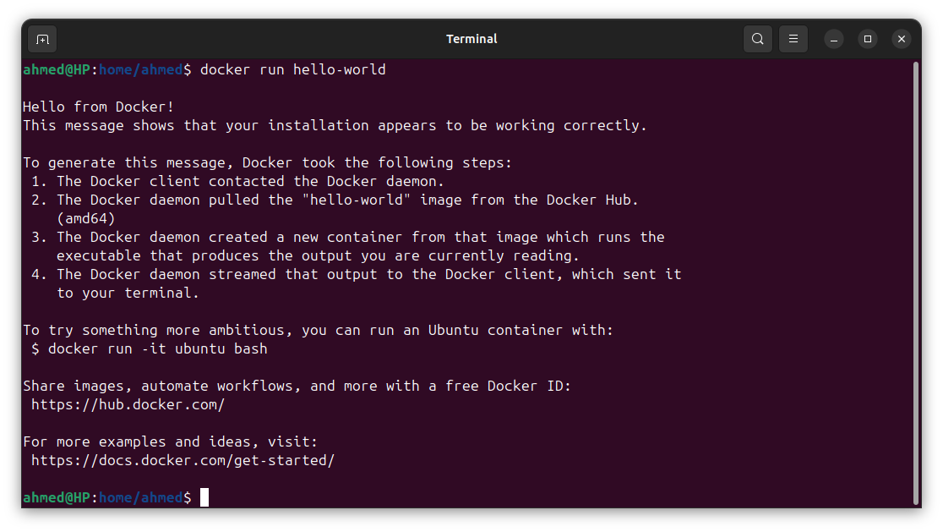

Problem 2:
- Run container centos or ubuntu in an interactive mode
- Run the following command in the container “echo docker ”
- Open a bash shell in the container and touch a file named hello-docker
- Stop the container and remove it. Write your comment about the file hello-docker
- Remove all stopped containers
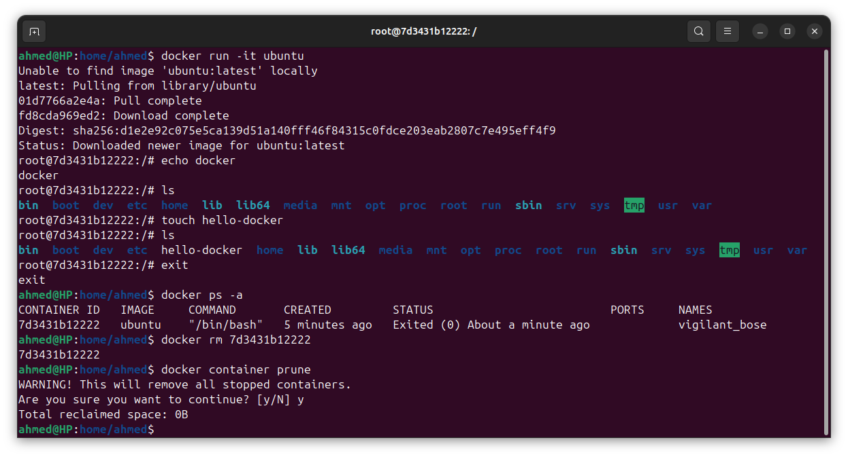
Problem 3:
- Deploy a MySQL database called app-database. Use the mysql latest image, and use the -e flag to set MYSQL_ROOT_PASSWORD to P4sSw0rd0!. The container should run in the background.

docker run --name app-database -e MYSQL_ROOT_PASSWORD=P4sSw0rd0! -d mysql

Problem 4:
- Run the image Nginx
- Add html static files to the container and make sure they are accessible
- Commit the container with image name IMAGE_NAME
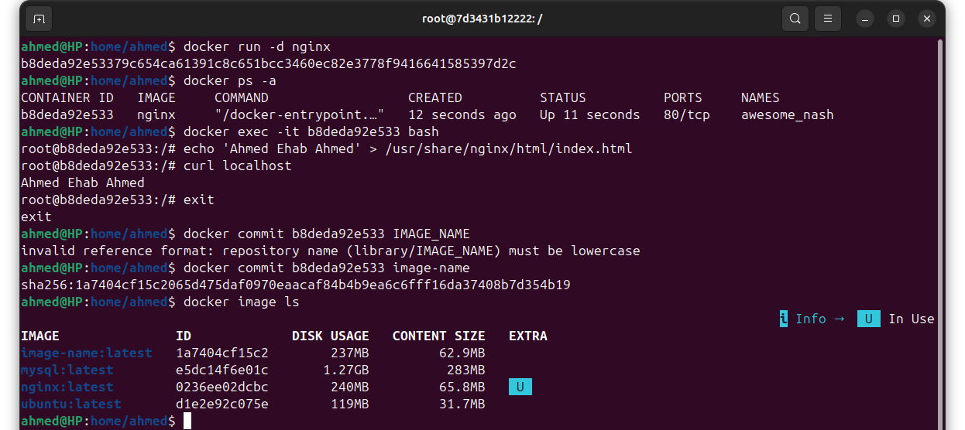

Problem 5 (Bonus) :
- run a container with 2 volumes,
- vol-1 to change in html file, vol-2 change in nginx configuration make the port 8090
- remove the conatiner, create new container with vol-1 for html files, and for vol-2 get the data from volume and then mount bind configuration
- make sure nginx is in running state

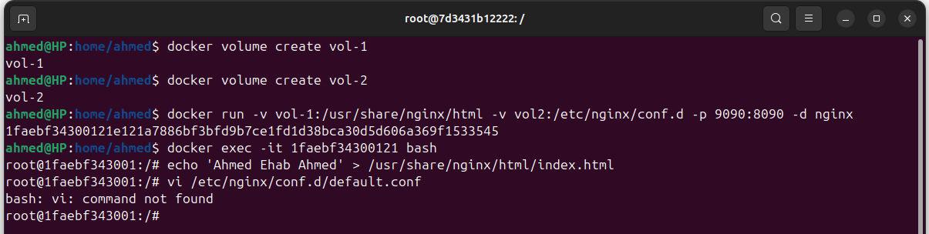
apt-get update
apt-get install vim -y
vim /etc/nginx/conf.d/default.conf
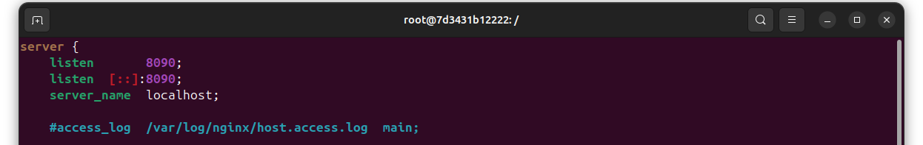

exit
docker rm -f 1faebf343001
mkdir -p ~/my-nginx-config
sudo cp -r /var/lib/docker/volumes/vol-2/_data/. ~/my-nginx-config/
